**Instruction Manual and Tutorial**

**Pre-Requisites**:

Python 3

Required Python Modules:

numpy

matplotlib

scipy

math

It is highly recommended to install all of this software (Python and packages) through Anaconda Navigator. This will ensure that the Python software is set up correctly and all the packages needed are present.

Link:

https://www.continuum.io/downloads

**Limitations/requirements**

The data must be formatted in the same way as the “example.csv” file. This “example.csv” Excel file was generated by the Protein Thermal Shift (PTS) ver. 1.3 software, after analysis of the DSF data by that software. In the PTS software, use the “Export” option on the left hand side, then select only the “Boltzmann Fit” tab, choosing “.csv” as the export file type (not “.txt”).

**Installing and Opening**

First, download the folder from the internet and put it somewhere your computer. For this example it is placed in a folder called “example_folder”, located on the desktop. The PTS-generated Boltzmann fit data Excel file must be in the same folder as the .py file.

From this point, there are two options. If the full Anaconda installation was downloaded, you can launch the program out of Spyder (simply launch Anaconda, open Spyder, open the .py file, and the “Example.csv” sample file, and click the play button).

Alternatively, it can be launched through the command line by doing the following:

1. Make sure that the .py file opens as a text file. Do this by opening it once using notepad (Windows) or text edit (Mac).
2. Next, launch terminal or command line:

On a Mac, this can be done by pressing command+space on the keyboard, then typing “terminal”

On a PC, this can be done by searching “cmd” on the Start menu and selecting the command line.

1. Once open, navigate to where the files are saved. Do this by typing “cd” for change directory, followed by the path to your folder. Once in the correct folder, run the program by typing “python” followed by the name of the desired “ .py” file program.

Note: The names of the folders cannot contain certain characters, or they will not be recognized by the command line. White space (spaces, tabs, returns) are particularly problematic, so do not use them - use an underscore instead of a white space, if necessary.

**Output**

Both programs save a graph as a .tiff file in the same folder as the .py and the Excel file. The “all_ligands” program should also print the delta g values into the terminal/output as a list of values. An example of such a terminal output is given below: 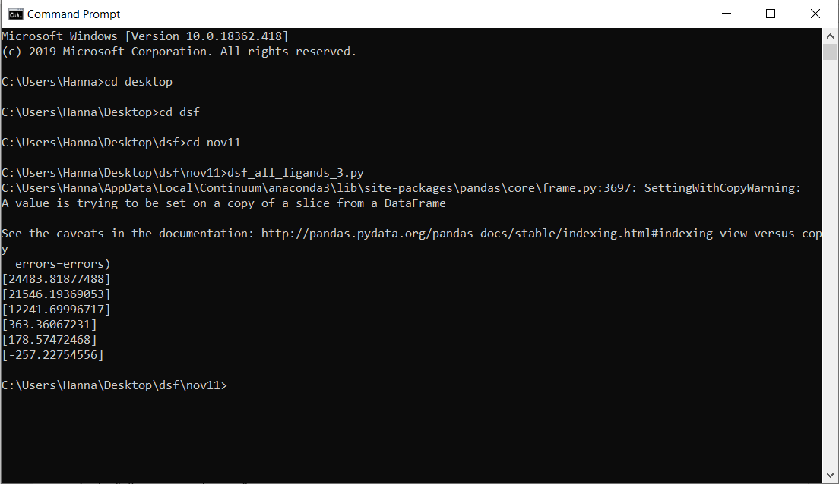

Depending on the experiment, these values can be used for further calculations. Provided is an Excel sheet that will calculate ligand Kd values using a linear equation as an example application.

Note: If you are running through spyder, there will be a blank non-functioning graph box. This function works through the command line, but not through this app. Just close it and get your graphs saved in the folder.

**Customizing and Adapting the output**

There are a few lines of code that can be changed in order to customize the output. The important ones are listed here.

*In the “all_ligands.py” program:*

Line 17: Replace the “Example.csv” file name with the filename of the data to be analyzed

Line 54: Replace the t_zero value (suggested to use the TmB value for the apo (unliganded) protein (in degrees Kelvin))

Line 88-94: Define which concentration of ligand used in the experiment is being analyzed

Line 258: Change the ligand names in the legend

Line 257: Change or add vertical lines to the graph (at the apo TmB, or some other reference temperature)

Line 88-93: If you used a plate that did not have 96 wells, you will need to adapt these to reflect what the coordinates of the cells you used. You may need to add or remove as needed.

*In the “all_concentrations.py” program:*

Line 17: Replace the “Example.csv” file name with the filename of the data to be analyzed

Line 52: Replace the t_zero value (suggested to use the TmB value for the apo (unliganded) protein (in degrees Kelvin))

Line 90: Define which ligand is being analyzed (change the “celllistX” X value to A, B, C, D. E. of F)

Line 123-130: Change the labels on the legend

Line 121: Change or add vertical lines to the graph (at the apo TmB, or some other reference temperature)

Line 75-80: If you used a plate that did not have 96 wells, you will need to adapt these to reflect what the coordinates of the cells you used. You may need to add or remove as needed.